**PUBLIC TRANSPORT OPTIMIZATION**

**INTODUCTION OF PUBLIC TRANSPORT OPTIMIZATION**

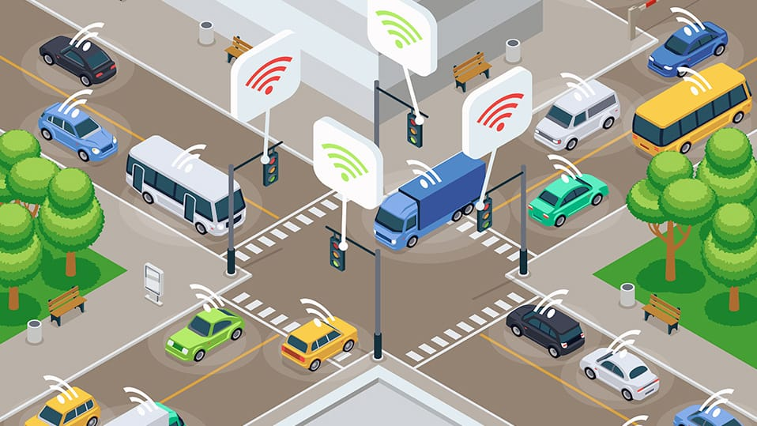

Public transport optimization refers to the process of improving the efficiency, accessibility, and overall performance of public transportation systems. This optimization can take many forms and may involve various aspects of public transport, including buses, trains, trams, subways, and more. The primary goals of public transport optimization are to enhance the quality of service for passengers, reduce operational costs, minimize environmental impacts, and promote sustainable urban mobility. Here are some key aspects of public transport optimization:

Route Planning and Scheduling: Optimizing routes and schedules is crucial to ensure that public transport services are both efficient and convenient. This involves analyzing passenger demand, traffic patterns, and travel times to create routes that minimize travel times and waiting times for passengers.

Fleet Management: Efficiently managing the fleet of vehicles used in public transport is essential. This includes monitoring vehicle maintenance, fuel consumption, and ensuring that the right type and number of vehicles are deployed on each route.

Real-time Monitoring and Control: Utilizing technology to monitor and control public transport in real-time can help optimize operations. GPS tracking, traffic monitoring, and automated dispatch systems can improve on-time performance and reduce delays.

Ticketing and Payment Systems: Implementing smart ticketing and payment systems can streamline passenger boarding and reduce fare evasion. These systems can also provide valuable data for optimizing routes and schedules.

Integration with Other Modes of Transportation: Public transport systems are often more efficient when they are integrated with other modes of transportation, such as cycling, walking, and ride-sharing services. This can create a seamless and sustainable transportation network.

Accessibility and Inclusivity: Ensuring that public transport is accessible to all members of the community, including those with disabilities, is a crucial aspect of optimization. This may involve providing accessible vehicles, stations, and information.

Environmental Sustainability: Optimizing public transport systems to be more environmentally friendly is a growing concern. This can involve using electric or hybrid vehicles, implementing green infrastructure, and reducing emissions.

Data Analysis and Planning: Collecting and analyzing data on passenger behavior, usage patterns, and demographics can help planners make informed decisions about how to optimize routes and services to meet the needs of the community.

Public Engagement: Involving the community and stakeholders in the planning and decision-making process is essential. Public input can help identify areas for improvement and ensure that the system meets the needs of the people it serves.

Cost-Benefit Analysis: Public transport optimization often involves making investments in infrastructure and technology. Conducting cost-benefit analyses can help decision-makers determine which optimizations are most cost-effective and beneficial in the long run.

Public transport optimization is a complex and ongoing process that requires collaboration between transportation authorities, government agencies, and other stakeholders. The ultimate goal is to create a reliable, efficient, and sustainable public transportation system that enhances the quality of life for residents and reduces the negative impacts of congestion and pollution in urban areas.

**INNOVATION OF PUBLIC TRANSPORT OPTIMIZATION**

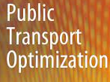

Incorporating machine learning algorithms to improve arrival time prediction accuracy based on historical data and traffic conditions is a great idea. It can lead to more accurate and real-time predictions, which can be incredibly valuable for various applications such as ride-sharing services, logistics, and navigation systems. Here are the steps you can take to implement this:

**Data Collection**:

Gather historical data on routes, including start and end points, timestamps, and actual arrival times.

Collect real-time data on traffic conditions, such as congestion, accidents, road closures, and weather.

**Data Preprocessing**:

Clean and preprocess the data to handle missing values, outliers, and inconsistencies.

Feature engineering: Extract relevant features from the data, such as time of day, day of the week, road types, and historical traffic patterns.

**Data Splitting**:

Split the data into training, validation, and test sets to evaluate model performance properly.

**Select Machine Learning Algorithms**:

Choose machine learning algorithms suitable for regression tasks. Common choices include:

Linear Regression

Decision Trees

Random Forest

Gradient Boosting (e.g., XGBoost, LightGBM)

Neural Networks

**Feature Scaling and Normalization**:

Normalize or standardize the input features to ensure that different features have similar scales.

**Model Training**:

Train your selected machine learning models on the training dataset.

Tune hyperparameters to optimize model performance, which may involve techniques like cross-validation.

**Model Evaluation**:

Evaluate the models on the validation dataset using appropriate metrics like Mean Absolute Error (MAE), Mean Squared Error (MSE), or Root Mean Squared Error (RMSE).

**Model Selection**:

Choose the best-performing model based on the evaluation results from the validation set.

**Hyperparameter Tuning**:

Fine-tune the selected model's hyperparameters further if needed.

**Test the Model**:

Evaluate the final model on the test dataset to assess its real-world performance.

**Real-time Data Integration**:

Integrate the trained model with a system that can receive real-time data updates on traffic conditions and user requests.

**Predict Arrival Times**:

Use the integrated model to predict arrival times based on current traffic conditions and user inputs.

**Continuous Monitoring and Updating**:

Continuously monitor model performance and update it as new data becomes available. Machine learning models can drift over time, so periodic retraining is essential.

**User Feedback**:

Collect user feedback and consider it for further model improvements.

**Privacy and Ethical Considerations**:

Ensure that you handle user data responsibly, considering privacy regulations and ethical concerns.

**Scalability**:

Design your system to be scalable, especially if you anticipate a large number of users and requests.

Remember that the success of your arrival time prediction system depends on the quality and quantity of data, the choice of algorithms, and the ongoing maintenance and monitoring of the system. Machine learning-based systems can provide accurate predictions, but they require careful planning and management to be effective in real-world applications.

PUBLIC TRANSPORT OPTIMIZATION

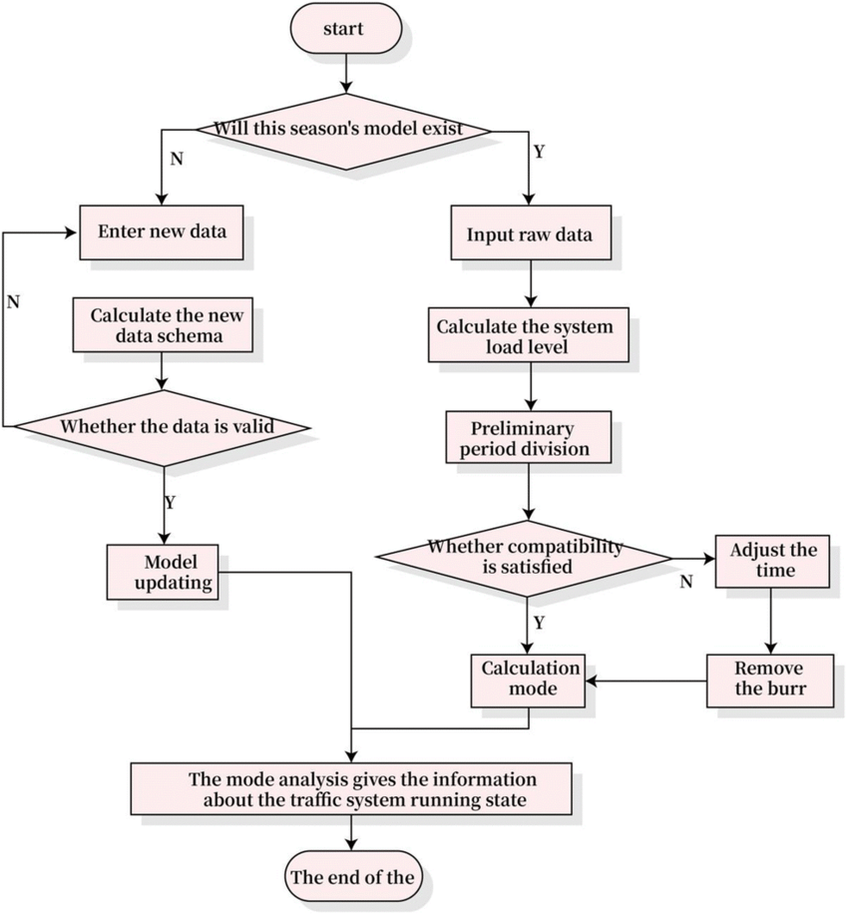

CIRCUIT

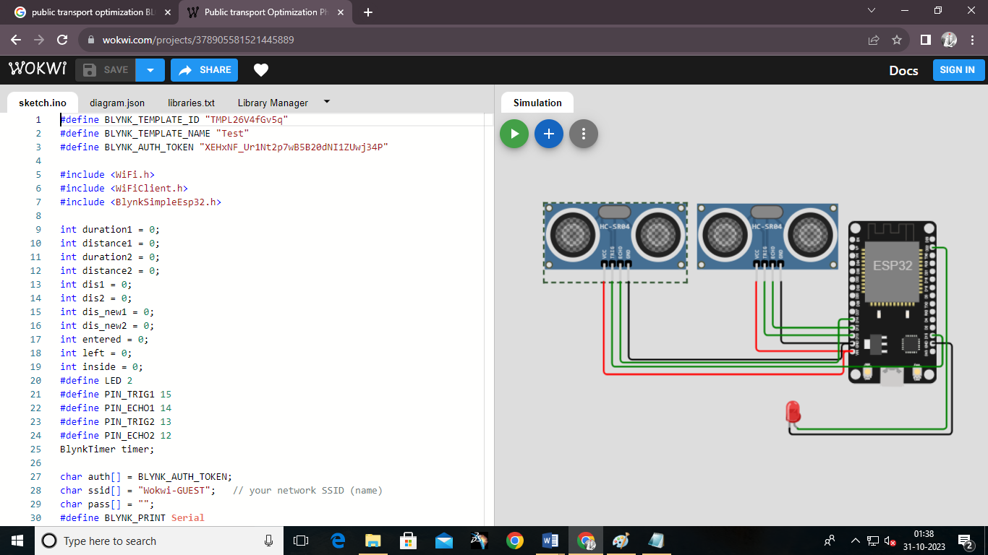

CODE

#define BLYNK_TEMPLATE_ID "TMPL26V4fGv5q"

#define BLYNK_TEMPLATE_NAME "Test"

#define BLYNK_AUTH_TOKEN "XEHxNF_Ur1Nt2p7wB5B20dNI1ZUwj34P"

#include <WiFi.h>

#include <WiFiClient.h>

#include <BlynkSimpleEsp32.h>

int duration1 = 0;

int distance1 = 0;

int duration2 = 0;

int distance2 = 0;

int dis1 = 0;

int dis2 = 0;

int dis_new1 = 0;

int dis_new2 = 0;

int entered = 0;

int left = 0;

int inside = 0;

#define LED 2

#define PIN_TRIG1 15

#define PIN_ECHO1 14

#define PIN_TRIG2 13

#define PIN_ECHO2 12

BlynkTimer timer;

char auth[] = BLYNK_AUTH_TOKEN;

char ssid[] = "Wokwi-GUEST";   // your network SSID (name)

char pass[] = "";

#define BLYNK_PRINT **Serial**

long get_distance1() {

  // Start a new measurement:

  digitalWrite(PIN_TRIG1, HIGH);

  delayMicroseconds(10);

  digitalWrite(PIN_TRIG1, LOW);

  // Read the result:

  duration1 = pulseIn(PIN_ECHO1, HIGH);

  distance1 = duration1 / 58;

  return distance1;

}

long get_distance2() {

  // Start a new measurement:

  digitalWrite(PIN_TRIG2, HIGH);

  delayMicroseconds(10);

  digitalWrite(PIN_TRIG2, LOW);

  // Read the result:

  duration2 = pulseIn(PIN_ECHO2, HIGH);

  distance2 = duration2 / 58;

  return distance2;

}

void myTimer() {

**Serial**.println("100");

  dis_new1 = get_distance1();

  dis_new2 = get_distance2();

  if (dis1 != dis_new1 || dis2 != dis_new2){

**Serial**.println("200");

    if (dis1 < dis2){

**Serial**.println("Enter loop");

      entered = entered + 1;

      inside = inside + 1;

      digitalWrite(LED, HIGH);

      Blynk.virtualWrite(V0, entered);

      Blynk.virtualWrite(V2, inside);

      dis1 = dis_new1;

      delay(1000);

      digitalWrite(LED, LOW);

    }

    if (dis1 > dis2){

**Serial**.println("Leave loop");

      left = left + 1;

      inside = inside - 1;

      Blynk.virtualWrite(V1, left);

      Blynk.virtualWrite(V2, inside);

      dis2 = dis_new2;

      delay(1000);

    }

  }

}

 void setup() {

**Serial**.begin(115200);

  pinMode(LED, OUTPUT);

  pinMode(PIN_TRIG1, OUTPUT);

  pinMode(PIN_ECHO1, INPUT);

  pinMode(PIN_TRIG2, OUTPUT);

  pinMode(PIN_ECHO2, INPUT);

  Blynk.begin(auth, ssid, pass, "blynk.cloud", 8080);

  timer.setInterval(1000L, myTimer);

}

void loop() {

  Blynk.run();

  timer.run();

}

**OUTPUT**



**ADVANTAGES OF PUBLIC TRANSPORT OPTIMIZATION IN MACHINE LEARNING**

* Improved Efficiency: Machine learning algorithms can analyze historical data to optimize routes, schedules, and capacity utilization, leading to more efficient public transport systems. This results in reduced waiting times, shorter travel durations, and increased passenger satisfaction.
* Cost Reduction: By optimizing routes and schedules, public transport providers can reduce operational costs, such as fuel consumption and labor expenses. This can lead to more cost-effective and sustainable transportation services.
* Real-time Updates: Machine learning can continuously analyze data from various sources, such as GPS trackers and passenger feedback, to provide real-time updates on bus or train locations, delays, and other important information. Passengers can make informed decisions and reduce waiting times.
* Predictive Maintenance: Machine learning can predict maintenance needs for public transport vehicles based on usage patterns and sensor data. This proactive approach reduces downtime and ensures that vehicles are in good working condition.
* Demand Forecasting: Machine learning models can analyze historical passenger data to predict future demand patterns. This allows transportation providers to adjust services to match expected demand, ensuring that vehicles are neither overcrowded nor underutilized.
* Reduced Traffic Congestion: Optimized public transport systems can encourage people to choose public transportation over private vehicles, reducing traffic congestion and air pollution in urban areas.
* Enhanced Safety: Machine learning can be used to monitor the safety of public transport systems by identifying potential risks, such as accidents, equipment failures, or security threats. This can improve passenger safety and overall system reliability.
* Accessibility and Inclusivity: Machine learning algorithms can help design public transport services that are more accessible to people with disabilities and those with specific mobility needs, ensuring inclusivity for all passengers.
* Sustainability: By reducing the carbon footprint of public transportation systems through optimization, machine learning can contribute to environmental sustainability and support efforts to combat climate change.
* Data-Driven Decision-Making: Public transport optimization using machine learning enables data-driven decision-making. Transportation providers can use insights gained from data analysis to make informed choices about system improvements and adjustments.
* Customer Experience: Passengers benefit from optimized public transport services with reduced waiting times, reliable schedules, and improved accessibility. This can lead to increased passenger satisfaction and loyalty.
* Revenue Generation: By attracting more passengers through improved services and better customer experiences, public transport providers can increase their revenue and potentially invest in further improvements.

**DISADVANTAGES OF PUBLIC TRANSPORT OPTIMIZATION IN MACHINE LEARNING**

* Data Dependency: Machine learning models for public transport optimization rely heavily on data, including historical travel patterns, weather conditions, traffic data, and passenger behavior. Inaccurate or incomplete data can lead to suboptimal results.
* Privacy Concerns: Collecting and analyzing extensive data on passengers can raise privacy concerns. Striking a balance between optimizing services and protecting passenger privacy is a challenge that transport authorities must address.
* High Initial Costs: Implementing machine learning solutions can be expensive, involving costs related to data collection, infrastructure, and the development of predictive models. Smaller public transport agencies or cities with limited budgets may find it challenging to adopt these technologies.
* Technical Challenges: Developing and maintaining machine learning models requires technical expertise. Some public transport agencies may lack the necessary skills and resources to implement and maintain these systems effectively.
* Algorithm Bias: Machine learning algorithms can perpetuate biases present in the data they are trained on, potentially leading to unfair or discriminatory outcomes. It's essential to carefully monitor and address biases in public transport optimization models to ensure equitable service delivery.
* Resistance to Change: Passengers and transportation staff may resist changes brought about by optimization efforts, as they may be accustomed to existing systems, routes, and schedules. Implementing changes can be met with resistance and require effective communication and transition strategies.
* System Complexity: Integrating machine learning optimization into existing public transport systems can be complex, as it often involves multiple stakeholders, legacy infrastructure, and various technical challenges.
* Uncertainty and Variability: Public transport systems can be affected by unforeseen events, such as accidents, extreme weather conditions, and special events. Machine learning models may struggle to adapt to these sudden changes, leading to suboptimal decisions.
* Over-Reliance on Technology: An overreliance on machine learning models can lead to a lack of human judgment and decision-making in managing public transport systems, potentially resulting in problems when the models encounter unexpected situations.
* Accessibility Gaps: Implementing technology-driven optimization solutions can inadvertently exclude passengers who do not have access to smartphones or the internet, limiting their ability to benefit from real-time information and services.
* Limited Generalization: Machine learning models may be trained on specific datasets and may not generalize well to different cities or regions with distinct transport characteristics. Customization is often required, which can increase implementation costs.
* Security Risks: As public transport systems become more connected and data-driven, they can become targets for cyberattacks, potentially disrupting services or compromising passenger data.

**Wokwi cad link :**

[**https://wokwi.com/projects/380091074008266753**](https://wokwi.com/projects/380091074008266753)

**Conclusion**

* **Enhanced Efficiency**: IoT sensors and devices enable real-time data collection and analysis, allowing public transport providers to optimize routes, schedules, and capacity utilization. This results in reduced waiting times, shorter travel durations, and increased operational efficiency.
* **Improved Passenger Experience**: Passengers benefit from real-time updates on vehicle locations, delays, and service changes, making their journeys more predictable and enjoyable. IoT technology can also enhance accessibility for people with disabilities and those with specific mobility needs.
* **Data-Driven Decision-Making**: IoT-driven public transport optimization fosters data-driven decision-making, helping transportation providers make informed choices about system improvements and adjustments. It allows for proactive maintenance and demand forecasting.
* **Sustainability and Environmental Impact**: IoT-driven optimization can lead to reduced traffic congestion and lower carbon emissions by encouraging more people to choose public transportation over private vehicles. This contributes to environmental sustainability and helps combat climate change.
* **Cost Savings**: Through optimized resource allocation and maintenance practices, public transport providers can reduce operational costs, making public transportation more cost-effective and financially sustainable.
* **Challenges and Considerations**: It's important to address challenges such as data privacy, security, bias in algorithms, and the potential resistance to change. Successful implementation requires collaboration among various stakeholders, technical expertise, and effective communication with passengers.
* **Customization and Adaptability**: Public transport optimization in IoT should be customized to suit the unique characteristics and needs of each city or region. It should also be adaptable to unforeseen events and changing urban dynamics.